### **List of Arithmetic Instructions in PLC:**

* Addition: ADD
* Subtraction: SUB
* Multiplication: MUL
* Division: DIV
* Return Fraction: MOD
* Absolute: ABS
* Square Root: SQRT
* Square: SQR
* Exponential: EXP
* Natural Logarithm: LN
* Sine Value: SIN
* Cosine Value: COS
* Tangent Value: TAN
* Arc Sine Value: ASIN
* Arc Cosine Value: ACOS
* Arc Tangent Value: ATAN

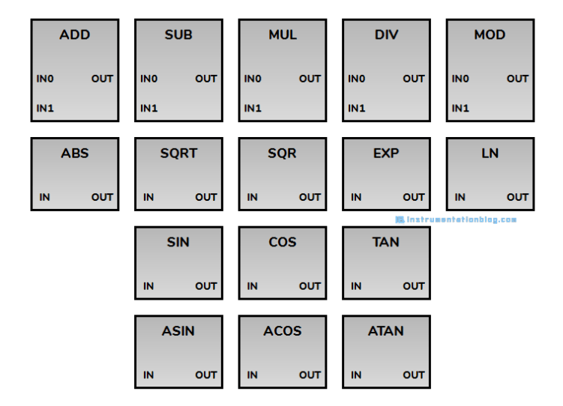

**Addition: ADD**Adds the two values, IN0 with IN1, and stores the resulting value in the OUT.

**Subtraction: SUB**Subtracts the value of IN1 from IN0 and stores the resulting value in the OUT.

**Multiplication: MUL**Multiplies the two values, IN0 with IN1, and stores the resulting value in the OUT.

**Division: DIV**Divides the value of IN1 from IN0 and stores the resulting value in the OUT.

The input and output values must be Integer or Floating Point value in ADD, SUB, MUL, and DIV instructions.

**Return Fraction: MOD**Divides the value of IN1 from IN0 and stores the remainder value in the OUT.

The input and output values must be the Integer value in the MOD instruction.

**Absolute: ABS**Returns the absolute value of IN in the OUT.

**Square Root: SQRT**Returns the square root value of IN in the OUT.

**Square: SQR**Returns the square value of IN in the OUT.

**Exponential: EXP**Returns the exponential value of IN to the base e in the OUT.

**Natural Logarithm: LN**Returns the natural logarithm value of IN in the OUT.

**Sine Value: SIN**Returns the sine value of IN in the OUT.

**Cosine Value: COS**Returns the cosine value of IN in the OUT.

**Tangent Value: TAN**Returns the tangent value of IN in the OUT.

**Arc Sine Value: ASIN**Returns the arcsine value of IN in the OUT.

**Arc Cosine Value: ACOS**Returns the arc cosine value of IN in the OUT.

**Arc Tangent Value: ATAN**Returns the arctangent value of IN in the OUT.

The input and output values must be a Floating Point value in EXP, LN, SIN, COS, TAN, ASIN, ACOS, and ATAN instructions.

Adavantages of plc over relay:

**Advantages of PLC over Relays:**

1. PLC increases the reliability, flexibility, and accuracy of the automation system.
2. PLC (especially Compact PLC) has a lower cost associated with it as compared to the other automation technology. (For you note: there are two types of PLC- [Modular PLC and Compact PLC](https://dipslab.com/difference-between-compact-modular-plc/).)
3. PLC software has good capabilities and flexibility for programming. Even, you can easily make the modification in the existing program at any time.
4. Programming used for PLC is easy to write and understand. There are [various Programming languages](https://dipslab.com/different-types-plc-programming-languages/) used in PLC. Out of them, [Ladder diagram](https://dipslab.com/introduction-parts-ladder-diagram-plc/) (LD) PLC programming is easiest.
5. PLC has the ability to easily communicate and connect with the computer. For communication, you can use various standard [communication protocols](https://dipslab.com/plc-communication-protocols-used-industry/).
6. PLC does not take much space. It occurs smaller in size, especially compact PLC.
7. Fast operation (no booting time) are the most important advantages as compared to alternative technologies.
8. PLC has low maintenance associated with it.
9. It gives supervisory control capability.
10. In the PLC system, we require less and simple wiring as compare to the other systems.
11. Modular PLC design makes development easy over the compact PLC.
12. Modification is possible in modular PLC. You can easily make the changes in an already implemented design.
13. It has remote control capability.
14. It gives a fast response to the connected system.
15. It performs the operation in a simple to the complex control system.
16. It has good computational function capabilities with the help of PLC[programming instructions](https://dipslab.com/plc-programming-instructions/).
17. PLC has a fast scan time (near about 10-15 ms for compact PLC). It requires very less operation time to perform any task.
18. PLC is good for building a small project as it takes less time.
19. You can add extra function modules to enhance the flexibility and performance of the PLC (in modular PLC) system.
20. In the case of PLC design, if anything goes wrong, one can easily troubleshoot the problem.
21. It can sustain in a robust environment with less maintenance.
22. In the PLC, we can visualize the operation of [input and output modules](https://dipslab.com/plc-input-output-modules/) of the automation system.

**DISPLACEMENT SENSORS**

Displacement sensors are con tact type sensor

**Types of Displacement sensors:**

Potentiometer

Strain gauge

Capacitive sensors

Linear variable differential transformer

### ***Flow control circuit: Meter-in***

Meter-in flow control circuit represents the controlling of fluid flow just before fluid enters to the actuator with the help of flow control valve. In meter-in flow control circuit, flow control valve will be installed in such a way that fluid flow to the actuator could be controlled or we can also say that there could be a restriction in fluid flow to the actuator.

Let us consider meter-in circuit for controlling the flow of fluid and hence speed of actuator e.g. hydraulic cylinder in following circuit. We can see here the bypass check valve that will force the fluid to flow through the adjustable orifice before fluid enters to the actuator i.e. hydraulic cylinder here.

Figure showing the meter-in flow control hydraulic circuit, first circuit represent the rest position of cylinder while pump will be in running condition. Second circuit represents the extension of hydraulic cylinder.

Therefore, speed of an actuator will be controlled here by controlling the flow of fluid before it enters to the actuators with the help of flow control valve which will be basically an adjustable orifice with bypass check valve as shown in above hydraulic circuit.

Let us consider, flow control valve is not provided then in that case flow of fluid and thereby extension as well as retraction of actuator i.e. cylinder will be carried out with unrestricted rate.

Movement of actuator during extension and retraction will be controlled by providing flow control valve as we have seen above. When fluid flow direction will be reversed in that situation, fluid will flow through the check valve and hence will bypass the flow control valve.

Meter-in flow control circuit will have quite precise control if load is resistive load but if there will be overrunning load then in that situation meter-in circuit will not be able to control the actuator speed.

In case of overrunning load, actuator will move faster and hydraulic circuit will not be able to fill it with hydraulic fluid and hence cavitation phenomena will be possible over there.

Meter-in flow control circuit applications could be seen in feeding welding machine, grinder table and also in milling machines.

### ***Flow control circuit: Meter-out***

As we have discussed above, if load on actuator is overrunning load in that situation meter-in flow control circuit will not be able to control the speed of actuator because overrunning load on actuator will make actuator rod i.e. cylinder rod to extend due to weight of vertical load i.e. overrunning load.

Flow control valve will be installed on discharge end or return side of actuator i.e. cylinder in order to control the discharge of fluid flow. Meter-out flow control circuit will control the flow of fluid leaving the actuator.

Figure showing below the meter-out flow control circuit, first circuit represent the rest position while pump is in running situation. When DC valve will be operated, we can see the second circuit to determine the fluid flow to the cylinder through the check valve. Fluid will flow via check valve by bypassing the flow control valve. When fluid will leave the cylinder, fluid will not be able to flow via check valve and will be restricted by an adjustable orifice.

Therefore actuator speed will be controlled in meter-out circuit by restricting the flow of fluid leaving the actuator. Meter-out circuit will work successfully with resistive load and also with overrunning load or running away load because actuator will not be able to move faster than fluid discharge it permits.

***PLC Program SCAN***

## How Does a PLC work?

The working of a programmable logic controller can be easily understood as a cyclic scanning method known as the scan cycle.

Block Diagram of How A PLC Works

A PLC Scan Process includes the following steps

* The operating system starts cycling and monitoring of time.
* The CPU starts reading the data from the input module and checks the status of all the inputs.
* The CPU starts executing the user or application program written in relay-ladder logic or any other PLC-programming language.
* Next, the CPU performs all the internal diagnosis and communication tasks.
* According to the program results, it writes the data into the output module so that all outputs are updated.
* This process continues as long as the PLC is in run mode.

## Types of Flow Control Valves

## ***Types of Flow Control Valves***

Following are the types of flow control valves:

1. Gate valve
2. Plug valve
3. Needle valve
4. Non-return valve
5. Butterfly valve
6. Pressure compensated flow control valves
7. Pinch valve
8. Globe valve
9. Diagram valve
10. Ball valve

### #1 Gate Valve

The valve controls the flow of the oil in a pipe by moving a flat plate called a gate or disc valve. Gate is built perpendicular to the length of the pipe with the help of a handwheel.

This mechanism is achieved by connecting the gate with the handwheel through a threaded spindle that rotates in the valve body. The advantage of a gate valve is that it offers little or no resistance to flow when it is fully open. It is usually made up of gunmetal.

### #2 Plug Valve

As the name suggests, this valve is having a plug. This plug can be turned to move its ports to control the flow of oil and it features to reduce the friction between the plug face and the body seat when the turning of the plug.

The valve consists of a tapered wedge mechanically seated in the body. The tapered edge has a rectangular window. When the valve is fully open rectangular window aligns itself with the holes running through the valve body.

### #3 Needle Valve

It is a kind of screw-down stop valve. Its use is restricted to small sizes which have the body ends in line or right angles with each other or maybe oblique type.

Here disc is in the form of needlepoint. By rotating the handwheel, the tapered needle advances, and the area of the valve seat decreases. Hence the oil flow is gradually reduced. These valves are used in hydraulic systems in lines of delicate pressure gauges.

### #4 Non-return Valve

The non-return valve permits flow in one direction and stops the flow completely in one direction and stops the flow completely in one direction. It consists of a valve body, a poppet, a spring, and a seat.

When the force of fluid is available at the inlet port exceeds the strength of the spring and the backpressure of oil the poppet is pushed up and the valve opens to permit the flow through it. When the oil is flow is reversed, the valve [piston is pushed](https://www.theengineerspost.com/types-of-pistons-working-principle/) back to its seat, completely blocking the flow.

### #5 Butterfly Valve

The butterfly valve has a circular disc that can be rotated through one complete revolution. The circular disc has a diameter equal to that of a pipe.

The valve is connected across both faces by two pipes with flanges. A circular disc is made to rotate around an axis passing through the vertical diameter of the disc. This type of flow control valve is used for controlling moderate flow.

### #6 Pressure Compensated Flow Valve

The pressure compensation flow valve provides a uniform volume flow rate independent of the pressure drop across the valve. On the other hand, the non-pressure-compensated valves have a variable flow rate that changes as the pressure in the valve fluctuates.

### #7 Pinch Valve

These are types of flow control valves, which are inexpensive and are used in almost all industries. It consists of flexible elements such as rubber tubes for sealing purposes. They are designed to give a tight seal around trapped solids with their flexibility, these rubber tubes are the moistened part in a pinch valve.

Pinch valves are perfect for liquids that contain large amounts of suspended solids. The valve body acts as a built-in actuator, reducing the need for expensive operators such as pneumatic, hydraulic, or electric operators.

### #8 Globe Valve

These are considered valuable for starting, stopping, and regulating the flow in a linear motion. Globe valves are used for throttling applications because the disc of the valve can be completely removed from the flowline and are also capable of closing the flowline completely.

Unlike the other types that are straight-through valves, these valves produce slightly high-pressure drops. The closure in a globe valve is opened by means of a plug that covers a flat bottom and is then lowered onto a horizontal seat in the center of this valve. The plug in the globe valve lifts when the user opens it, and this allows the fluid to flow.

### #9 Diaphragm Valve

These valves are built to handle conditions that require erosive, corrosive, and dirty services. It consists of a flexible disc that reaches the top of the valve body along with the seat to form a seal. These are used to control the opening or closing of the valve.

These valves work by an elastomeric diaphragm in the valve body, rather than an elastomeric liner, which is [attached to a compressor](https://www.theengineerspost.com/types-of-air-compressors/) to isolate the closure element from the fluid flow. This gives the advantage that they feature a leak-proof seal and are easy to maintain.

### #10 Ball Valve

Ball valves are commonly used in a variety of industries because of their low cost, durability, and excellent closing capability. These are similar to a butterfly valve, they are not suitable for flow control applications as they require high accuracy and control.

This is because a high level of torque is required to open and close a ball valve which prevents an operator from making fine adjustments. The ball valve is used for filling a tank with reasonable accuracy. A trunnion or V-port ball valve design is usually the best type.

**Timers and counters are internal instructions that provide the same functions as timing relays and counters. They are used to activate or de-activate a device after a preset interval of time.**

## Timers and Counters

The timer is assigned an address as well as being identified as a timer. Also included, as part of the timer instruction is the time base of the timer, the timer’s preset value, and the accumulated value.

The timer instructions include:

## Timer On-Delay (TON)

This instruction is programmed to provide time delay action. Once the rung has continuity, the timer begins counting time-based intervals and times until the accumulated value equals the preset value.

When the accumulated time equals the preset time, the output is energized, and the timed output contact associated with the output is closed. The timed contact can be used throughout the program as an NO or NC contact.

The accumulated value is reset when rung condition goes false.

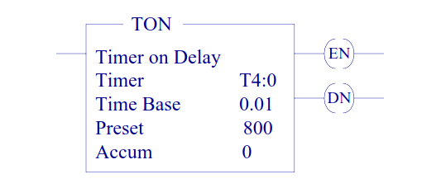

For SLC-500 processor the time base can be selected as 0.01 sec or 1.0 sec.

The control word uses three control bits:

#### Enable (EN) bit

The enable bit (EN) is set when rung conditions are true; it is reset when the rung condition becomes false.

#### Done (DN) bit

The done bit (DN) is set when the accumulated value is equal to the preset value. It is reset when rung condition becomes false.

#### Timer-timing (TT) bit

The Timer-timing bit (TT) is true when the timer is timing. When the timer is not timing the TT bit is false.

## Timer Off-Delay (TOF)

This instruction is programmed to provide time delay action. If the rung does not have continuity, the timer begins counting time-based intervals and times until the accumulated value equals the preset value.

When the accumulated time equals the preset time, the output is energized, and the timed output contact associated with the output is closed. The timed contact can be used throughout the program as an NO or NC contact.

The accumulated value is reset when rung condition goes true.

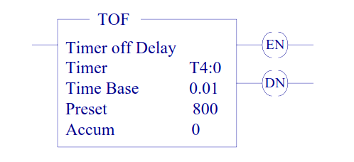

The done bit (DN) is set when the accumulated value is equal to the preset value. It is reset when rung condition becomes true. The enable bit (EN) is set when rung conditions are true; it is reset when the rung condition becomes false.

## Counters

Counters are similar to timers, except that they do not operate on an internal clock, but are dependent upon external or program sources for counting. The counter is assigned an address as well as being identified as a counter.

Also included, as part of the [counter instruction](https://instrumentationforum.com/t/example-for-counters-logics-in-plc/8622) is the counter’s preset value as well as the current accumulated count for the counter. There are two basic types of counters, one that counts up and another one that can count down.

### Count Up (CTU) and Count Down (CTD)

The up-counter output instruction will increment by one and the down-counter output instruction will decrement by one each time the counted event occurs.

These events could be caused by the number parts traveling past a detector or a limit switch. When the accumulated counts equal the preset count, the output is energized, and the counter output is closed.

The counter contact can be used throughout the program as an NO or NC contact

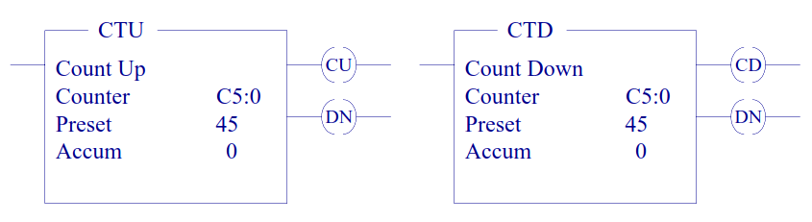

The done bit (DN) is set and remains set when the accumulated value is equal to the preset value. It is reset when rung condition becomes true.

The count up enable bit (CU) or the count down enable is set when rung conditions are true; it is reset when the rung condition becomes false or the appropriate reset instruction is enabled.

#### Counter and Timer Reset (RES)

The [RES] instruction is used to reset the timing and counting instruction accumulated values. A rung containing an NO or an NC contact together with the [RES] instruction is used.

The [RES] instruction must be given the same reference address as the related timer or counter. When the [RES] instruction is enabled, the counter accumulated value is reset.

## How Do Industrial Pneumatic Systems Work?

## ***How Do Industrial Pneumatic Systems Work?***

If you have ever used a bicycle pump then you have seen the basic application of pneumatics. Many companies today incorporate industrial pneumatics into their machines. They have become so popular that you can find them in everyday items such as nail guns and vacuum cleaners.  
  
A pneumatic system is a machine that uses pressurized air to control movements such as holding, moving, and forming materials together. Pneumatic equipment relies primarily on large amounts of compressed air to perform. It is important for many machines to carry and maintain constant air production.

**In general, most pneumatic systems are composed of:**

1. Compressor
2. Receiver
3. Valves
4. Actuators

### Compressor

An air compressor is a pneumatic tool that converts the air we breathe into compressed air. The pressurized air is then used throughout the pneumatic system. Usually, the air compressor is fueled by a gas tank that forces air into the system to produce pressurized air.There are many types of air compressors available to meet your desired pressure and flow rate of the air. The different types of air compressors available are piston, rotary, centrifugal, and axial flow.

### Receiver

Air receivers are what their name indicates. It receives air from the compressor and stores it in a bigger tank called the air receiver. The air receiver can smooth the flow of air and keep it cool as it enters the tank. A large tank is able to dissipate heat much more quickly than a smaller tank. To compensate for the loss of air, the air receiver stores the compressed air under higher pressure. This ensures the delivery of the required energy needed.

### air valve

Air Valves

[Air valves](https://trimantec.com/collections/pneumatic-valves) are an important pneumatic component because they stop and change the direction of air. They control the direction of airflow in order to move the actuator. Pneumatic systems may carry one or many valves. These can be [manual](https://trimantec.com/collections/manual-and-mechanical-air-valves) like a [foot valve](https://trimantec.com/collections/foot-pedal-air-valves) or they can be electrical like a [solenoid valve](https://trimantec.com/collections/solenoid-air-valves).

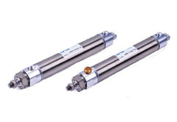

Pneumatic Actuators

[Actuators](https://trimantec.com/collections/pneumatic-actuators-and-air-cylinders) are simply the "movers” or the required movement of the pneumatic system. These output devices can be in the form of [air cylinders](https://trimantec.com/collections/airtac-pneumatic-round-body-cylinders) or even robotic arms that move and lift materials or drill bits. Most actuators move in a straight linear path.

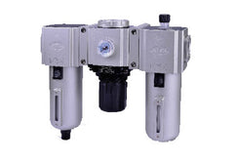

Air Preparation

In order to maximize the performance of your industrial pneumatic system, [air preparation](https://trimantec.com/collections/pneumatic-air-preparation) is necessary. Maintaining clean and dry air throughout your entire pneumatic system will extend its service life. Industrial applications such as clamping, positioning and lifting require constant high-quality air running throughout the system. Proper air preparation includes components such as [filters](https://trimantec.com/collections/air-filters), [regulators](https://trimantec.com/collections/air-pressure-regulators), and sometimes [lubricators](https://trimantec.com/collections/air-lubricators).